**PROBLEM STATEMENT**

**CHARTS REQUIREMENT**

We would like to visualize various aspects of our pizza sales data to gain insights and understand key trends. We have identified the following requirements for creating charts:

1. Daily Trend for Total Orders:  
   Create a bar chart that displays the daily trend of total orders over a specific time period. This chart will help us identify any patterns or fluctuations in order volumes on a daily basis.
2. Monthly Trend for Total Orders:  
   Create a line chart that illustrates the hourly trend of total orders throughout the day. This chart will allow us to identify peak hours or periods of high order activity.
3. Percentage of Sales by Pizza Category:  
   Create a pie chart that shows the distribution of sales across different pizza categories. This chart will provide insights into the popularity of various pizza categories and their contribution to overall sales.

**KPI’s REQUIREMENT**

We need to analyze key indicators for our pizza sales data to gain insights into our business performance. Specifically, we want to calculate the following metrics:

1. Total Revenue: The sum of the total price of all pizza orders.
2. Average Order Value: The average amount spent per order, calculated by dividing the total revenue by the total number of orders.
3. Total Pizzas Sold: The sum of the quantities of all pizzas sold.
4. Total Orders: The total number of orders placed.
5. Average Pizzas Per Order: The average number of pizzas sold per order, calculated by dividing the total number of pizzas sold by the total number of orders.

**SOLUTIONS**

**PIZZA SALES SQL QUERIES**

**A. KPI’s**

**1. Total Revenue:**

SELECT SUM(total_price) AS Total_Revenue FROM pizza_sales;

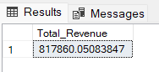

**2. Average Order Value**

SELECT (SUM(total_price) / COUNT(DISTINCT order_id)) AS Avg_order_Value FROM pizza_sales

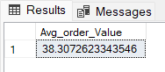

**3. Total Pizzas Sold**

SELECT SUM(quantity) AS Total_pizza_sold FROM pizza_sales

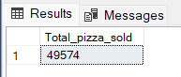

**4. Total Orders**

SELECT COUNT(DISTINCT order_id) AS Total_Orders FROM pizza_sales

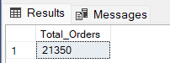

**5. Average Pizzas Per Order**

SELECT CAST(CAST(SUM(quantity) AS DECIMAL(10,2)) /

CAST(COUNT(DISTINCT order_id) AS DECIMAL(10,2)) AS DECIMAL(10,2))

AS Avg_Pizzas_per_order

FROM pizza_sales

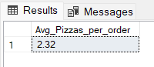

**B. Daily Trend for Total Orders**SELECT DATENAME(DW, order_date) AS order_day, COUNT(DISTINCT order_id) AS total_orders

FROM pizza_sales

GROUP BY DATENAME(DW, order_date)

***Output:***

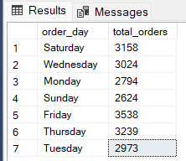

**C. Monthly Trend for Orders**

select DATENAME(MONTH, order_date) as Month_Name, COUNT(DISTINCT order_id) as Total_Orders

from pizza_sales

GROUP BY DATENAME(MONTH, order_date)***Output***

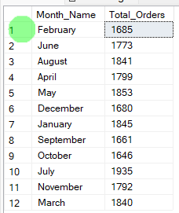

**D. % of Sales by Pizza Category**

SELECT pizza_category, CAST(SUM(total_price) AS DECIMAL(10,2)) as total_revenue,

CAST(SUM(total_price) * 100 / (SELECT SUM(total_price) from pizza_sales) AS DECIMAL(10,2)) AS PCT

FROM pizza_sales

GROUP BY pizza_category

***Output***

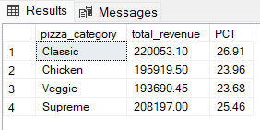

**E. % of Sales by Pizza Size**

SELECT pizza_size, CAST(SUM(total_price) AS DECIMAL(10,2)) as total_revenue,

CAST(SUM(total_price) * 100 / (SELECT SUM(total_price) from pizza_sales) AS DECIMAL(10,2)) AS PCT

FROM pizza_sales

GROUP BY pizza_size

ORDER BY pizza_size

***Output***

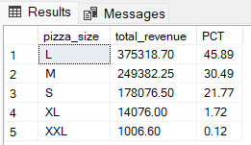

**F. Total Pizzas Sold by Pizza Category**

SELECT pizza_category, SUM(quantity) as Total_Quantity_Sold

FROM pizza_sales

WHERE MONTH(order_date) = 2

GROUP BY pizza_category

ORDER BY Total_Quantity_Sold DESC

***Output***

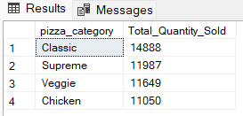

**G. Top 5 Pizzas by Revenue**

SELECT Top 5 pizza_name, SUM(total_price) AS Total_Revenue

FROM pizza_sales

GROUP BY pizza_name

ORDER BY Total_Revenue DESC

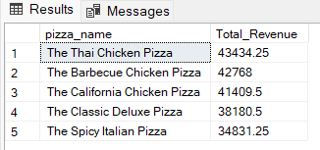

**H. Bottom 5 Pizzas by Revenue**

SELECT Top 5 pizza_name, SUM(total_price) AS Total_Revenue

FROM pizza_sales

GROUP BY pizza_name

ORDER BY Total_Revenue ASC

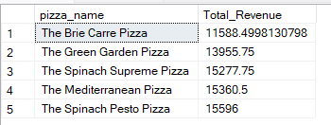

**I. Top 5 Pizzas by Quantity**

SELECT Top 5 pizza_name, SUM(quantity) AS Total_Pizza_Sold

FROM pizza_sales

GROUP BY pizza_name

ORDER BY Total_Pizza_Sold DESC

***Output***

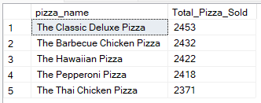

**J. Bottom 5 Pizzas by Quantity**

SELECT TOP 5 pizza_name, SUM(quantity) AS Total_Pizza_Sold

FROM pizza_sales

GROUP BY pizza_name

ORDER BY Total_Pizza_Sold ASC

***Output***

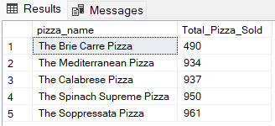

**K. Top 5 Pizzas by Total Orders**

SELECT Top 5 pizza_name, COUNT(DISTINCT order_id) AS Total_Orders

FROM pizza_sales

GROUP BY pizza_name

ORDER BY Total_Orders DESC

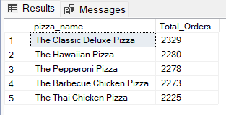

**L. Borrom 5 Pizzas by Total Orders**

SELECT Top 5 pizza_name, COUNT(DISTINCT order_id) AS Total_Orders

FROM pizza_sales

GROUP BY pizza_name

ORDER BY Total_Orders ASC

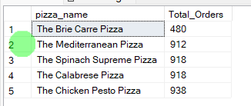

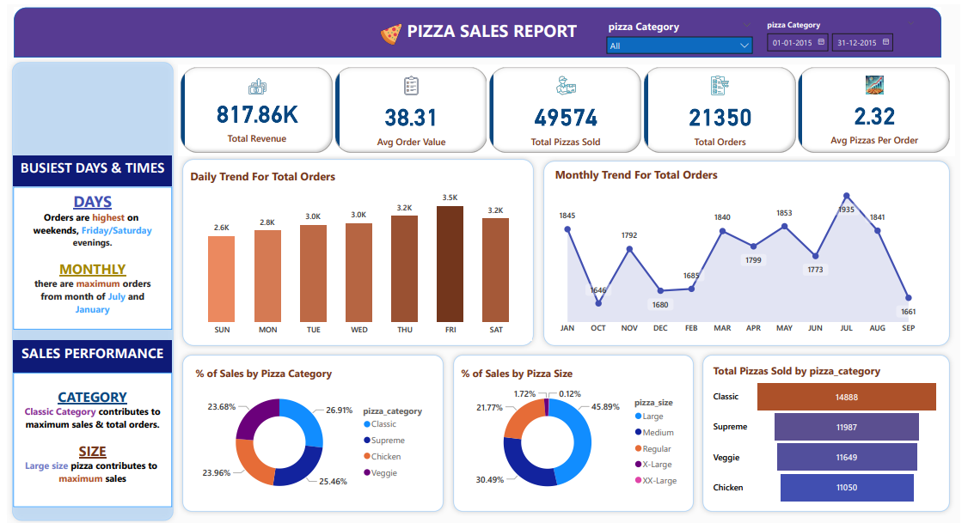DASHBOARD